**EXPERIMENT 1:**

**PROJECT TITLE DETAILS**

**AIM:**

To find a web based application that can be implemented over various web technologies.

**ABSTRACT:**

**Hospital Portal**

A doctor patient handling, managing system that helps doctors in their work and also patients to book doctor appointments and view medical progress. The system allows doctors to manage their booking slots online. Patients are allowed to book empty slots online and those slots are reserved in their name. The system manages the appointment data for multiple doctors for various date and times. Each time a user visits a doctor his/her medical entry is stored in the database by doctor. Next time a user logs in he may view his/her entire medical history as and when needed. At the same time a doctor may view patients medical history even bore the patient visits him. This allows for an automated patient doctor handling system through an online interface. Our system also consists of organ donor module. This module allows for organ donation registration as well as organ search. The module is designed to help urgent organ requirements through easy/instant searches.

**MODULES:**

* **Admin Login**: The system is under supervision of admin who manages the bookings made.
* **User login/registration**: Users have to first register themselves to login into the system.
* **Feedback**: The system has a feedback form, where user can provide feedback into the system.
* **Medical History**: System allows to update and view patient medical history.
* **Appointment availability check**: User can click on spaces to view the availability.
* **Doctor search**: Search for doctors available in the hospital
* **Diet Chart**: View different diet chart for each of the diseases.

**HARDWARE REQUIREMENTS:**

* Windows 10 (64-bit)
* RAM: 128 MB
* Disk space: 124 MB for JRE; 2 MB for Java Update
* Processor: Minimum Pentium 2 266 MHz processor
* Browsers: Internet Explorer 9 and above, Firefox

**SOFTWARE REQUIREMENTS**

* NetBeans
* TextEditor- Sublime,Brackets
* Windows 7 and above
* XAMPP server
* Web Browser- Chrome,Internet Exploerer

**EXPERIMENT 2:**

**WEBSITE STRUCTURE AND STATIC ELEMENT**

**AIM:**

To implement the website structure using html.

**PROCEDURE:**

1. Open NetBeans
2. Make html file
3. Write the structure using HTML
4. Save it in .html format
5. Open the file in any browser.

**SOURCE CODE:**

<!DOCTYPE html>

<html>

<head>

<meta content="text/html; charset=utf-8" http-equiv="Content-Type" />

<title>Untitled 1</title>

<link href="login.css" rel="stylesheet" type="text/css">

<script>

function validateForm() {

var x = document.forms["login"]["username"].value;

var y = document.forms["login"]["password"].value;

if (x == "" || y=="") {

alert("Name and password must not be left blank");

return false;

}

}

</script>

</head>

<body>

<header>

<div id="blueHeader">

<span id="title"> HospitalPortal</span>

<span id="headerNav"><a class="topNav" href="index.html" >Home</a>&nbsp;&nbsp;&nbsp; |&nbsp;&nbsp;&nbsp; <a class="topNav" href="login.html" >Login</a>&nbsp;&nbsp;&nbsp; |&nbsp;&nbsp;&nbsp; Appointment&nbsp;&nbsp; |&nbsp;&nbsp; Search</span>

<img src="stethoscope-simple-black-icon-512.png" alt="logo" id="blueLogo">

</div>

<img src="slider2.jpg" alt="doctors" id="doctors">

</header>

<main>

<table style="width: 100%">

<tr>

<td id="sideMenu">

<br><a href="Login.html" class="nav"> Login </a> <br><br>

<a href="registration.html"class="nav" > Patient Registration </a><br><br>

<a href="registrationDoctor.html" class="nav" > Doctor Registration </a><br><br>

<a href="MedicalHistory.html" class="nav"> Medical History </a> <br><br>

<a href="DoctorSearch.html" class="nav" > Doctor Search </a> <br><br>

<a href="bookAppointment.html" class="nav"> Book Appointment </a> <br><br>

</td>

<td id="login" >

<p align="Center"><h1>Login</h1></p>

<br><br>

<form name="login" onsubmit="return validateForm()" >

<label >

USERNAME:

<input type="text" name="username" align="center" >

</label>

<br><br>

<label>

PASSWORD:

<input type="password" name="password" align="center" >

</label>

<br><br>

<label>

USER TYPE:

<input type="radio" name="type" value="Patient" checked>Patient

<input type="radio" name="type" value="Doctor">Doctor

</label>

<br><br>

<input type="submit" name="" value="Login" style="background-color:#01A4EF; padding:5px; color:#FFFFFF">

</form>

</td>

</tr>

</table>

</main>

<footer>

<span class="auto-style1">Email&nbsp; </span><span id="preFooter">|&nbsp;&nbsp; Facebook&nbsp;&nbsp; |&nbsp;&nbsp; Twitter&nbsp;&nbsp; |&nbsp;

Google+ </span><br>

&copy; Copyright Arvind Narayan - RA1511020010043 - SRM University

</footer>

</body>

</html>

**OUTPUT:**

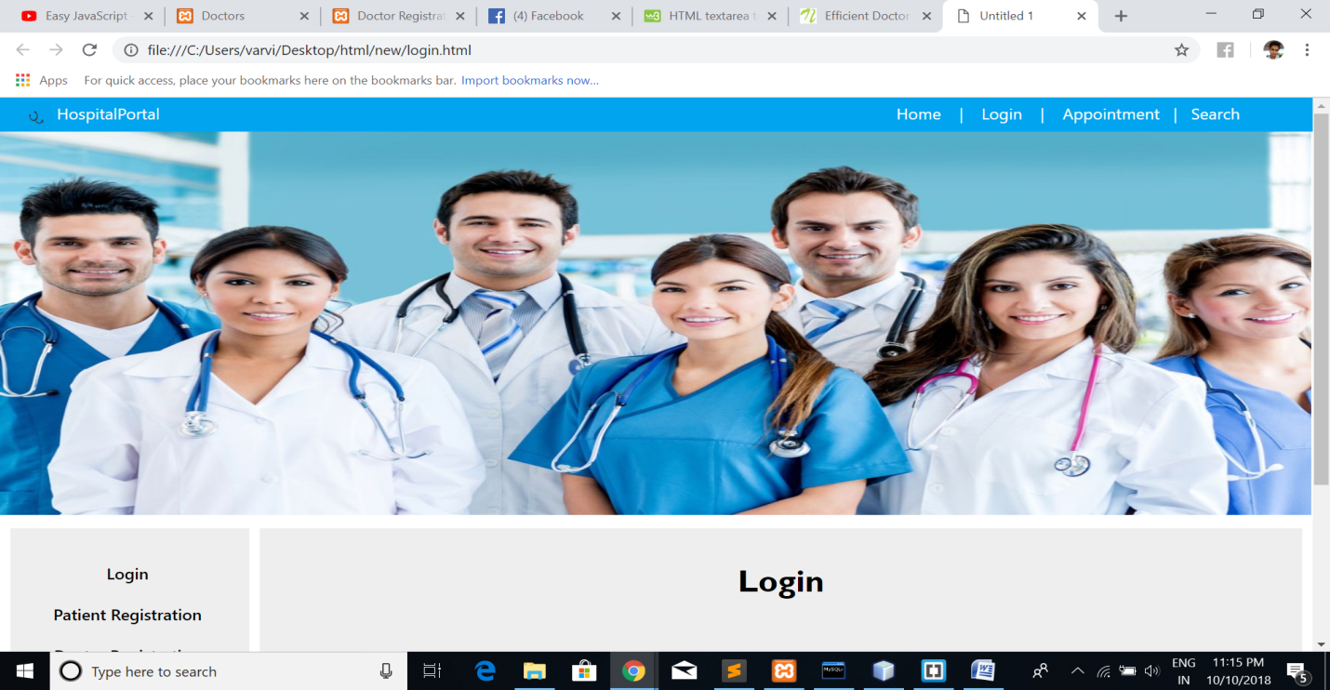

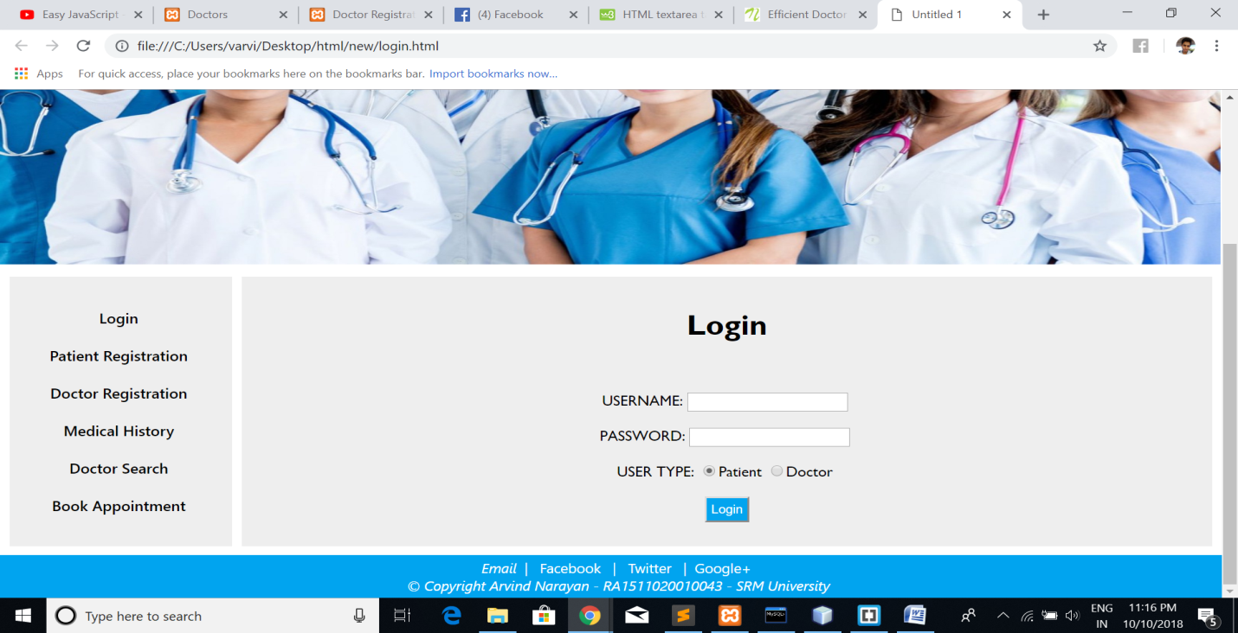

**RESULT:**

Hence the html tags have been implemented successfully.

**EXPERIMENT 3:**

**STYLING PAGE USING CSS**

**AIM:**

To style the structured page using CSS styling.

**PROCEDURE:**

1. Open Sublime
2. Make CSS file
3. Perform inline,internal,external styling
4. Save it in .css format
5. Add CSS file into HTML file.

**SOURCE CODE:**

body {

font-family: "Segoe UI", Tahoma, Geneva, Verdana, sans-serif;

font-weight: 500;

margin: 0 auto;

}

#blueHeader {

background-color: #01A4EF;

font-weight: 400;

color: white;

margin: 0px auto;

padding: 5px;

padding-left: 20px;

height: 25px;

}

#blueLogo {

width: 30px;

height: 30px;

float: left;

}

#title {

padding: 5px;

}

#headerNav

{

margin-left: 700px;

}

#doctors

{

width: 1262px;

height: 400px;

}

footer {

background-color: #01A4EF;

font-weight: 400;

color: white;

margin: 0px auto;

padding: 5px;

padding-left: 20px;

height: 40px;

font-style: italic;

text-align:center;

font-size: 15px;

}

td{

background-color: #eeeeee;

padding: 15px;

vertical-align: top;

}

table {

border-spacing: 10px;

}

#login{

align:center;

font-family:"Gill Sans", "Gill Sans MT", Calibri, "Trebuchet MS", sans-serif;

text-align:center;

}

#sideMenu {

width: 200px;

text-align:center;

}

#preFooter {

font-style: normal;

}

a {

font-family: "segoe UI", Tahoma, Geneva, Verdana, sans-serif;

color: #ffffff;

text-decoration:none;

}

a:hover.nav{

background:#01A4EF;

color:#FFFFFF;

}

a.nav {

color: #000000;

}

**OUTPUT**





**RESULT:**

Hence the inline, internal, external CSS have been implemented successfully.

**EXPERIMENT 4:**

**CLIENT SIDE VALIDATION USING JAVASCRIPT**

**AIM:**

To create dynamic page and perform validation using Javascript .

**PROCEDURE:**

1. Open Sublime
2. Create javascript file-internal external
3. Perform dynamic page using inbuilt functions and inner HTML
4. Perform validation using regular expression
5. Execute the file in browser.

**SOURCE CODE:**

<!DOCTYPE html>

<html>

<head>

<title></title>

<link href="bookAppointment.css" rel="stylesheet" type="text/css">

<script >

function validateForm(){

var fname = document.getElementById("fname").value;

var email = document.getElementById("email").value;

var phone = document.getElementById("phone").value;

var status = true;

document.getElementById("fnamemsg").innerHTML="";

document.getElementById("emailmsg").innerHTML="";

document.getElementById("phonemsg").innerHTML="";

if(phone == "") {

document.getElementById("phonemsg").innerHTML="Please fill out this field";

status=false;

}

if(email == "")

{

document.getElementById("emailmsg").innerHTML="Please fill out this field";

status=false;

}

return status;

}

function checkMail()

{

var email = document.getElementById("email").value;

if(/^[a-zA-Z._0-9]+@[a-zA-Z._]+(\.[a-zA-Z]{2,3})+$/.test(email)==false)

{

alert("Invalid email id");

document.getElementById("email").focus();

}

}

function checkNumber()

{

var phone = document.getElementById("phone").value;

document.getElementById("phonemsg").innerHTML="";

if(/^[+]?[0-9]{1,2}?[0-9]{10}$/.test(phone)==false)

{

alert("Invalid phone Number");

document.getElementById("phonemsg").innerHTML="Enter with Country code";

document.getElementById("phone").focus();

}

}

function checkCost()

{

var visitType = document.myf.visitType.value;

document.getElementById("costMsg").innerHTML="";

if(visitType=="Basic Consultancy")

{

document.getElementById("costMsg").innerHTML="Cost: Rs.400";

}

if(visitType=="Monthly Checkup")

{

document.getElementById("costMsg").innerHTML="Cost: Rs.200";

}

if(visitType=="New illness")

{

alert(visitType+": additional charges applicable");

document.getElementById("costMsg").innerHTML="Cost: Rs.200+additional charges";

}

}

</script>

</head>

<body>

<header>

<div id="blueHeader">

<span id="title" >HospitalPortal </span>

<span id="headerNav"><a href="index.html" style="color:#FFFFFF" >Home</a>&nbsp;&nbsp;&nbsp; |&nbsp;&nbsp;&nbsp; <a class="topNav" href="login.html" style="color:#FFFFFF">Login</a>&nbsp;&nbsp;&nbsp; |&nbsp;&nbsp;&nbsp; Appointment&nbsp;&nbsp; |&nbsp;&nbsp; Search</span>

<img src="stethoscope-simple-black-icon-512.png" alt="logo" id="blueLogo">

</div>

</header>

<div id="divpadding">

<form method="post" action="" onSubmit="return validateForm()" name="myf">

<label>First name: </label>

<input name="fname" disabled id="fname" type="text" placeholder="Your Name" />

<span id="fnamemsg"></span>

<br><br>

<label>Confirm Email: </label>

<input name="email" id="email" type="text" onchange="checkMail()">

<span id="emailmsg"></span>

<br><br>

<label>Phone: </label>

<input name="phone" id="phone" type="text" onchange="checkNumber()">

<span id="phonemsg"></span>

<br><br>

<label>

Book Appointment with:

<select name="dName">

<option value="Doctor 1">Doctor 1</option>

<option value="Doctor 2">Doctor 2</option>

<option value="Doctor 3">Doctor 3</option>

<option value="Doctor 4">Doctor 4</option>

</select>

</label>

<br><br>

<label>

Most convenient Day of week:<br>

<input type="checkbox" name="week" value="Monday">Monday</input><br>

<input type="checkbox" name="week" value="Tuesday">Tuesday</input><br>

<input type="checkbox" name="week" value="Wednesday">Wednesday</input><br>

<input type="checkbox" name="week" value="Thursday">Thursday</input><br>

<input type="checkbox" name="week" value="Friday">Friday</input><br>

<input type="checkbox" name="week" value="Saturday">Saturday</input><br>

<input type="checkbox" name="week" value="Sunday" checked>Sunday</input><br>

</label>

<label><br>

Prefered Timings:<br>

<input type="checkbox" name="Timings" value="8-10am">8-10am</input><br>

<input type="checkbox" name="Timings" value="10-12pm">10-12pm</input><br>

<input type="checkbox" name="Timings" value="4-6pm">4-6pm</input><br>

<input type="checkbox" name="Timings" value="6-8pm">6-8pm</input><br>

<input type="checkbox" name="Timings" value="8-10pm">8-10pm</input><br>

</label>

<br>

<label>

Type of Visit:<br>

<input type="radio" name="visitType" value="Basic Consultancy" onClick="checkCost()">Basic Consultancy<br>

<input type="radio" name="visitType" value="Monthly Checkup" onClick="checkCost()">Monthly Checkup<br>

<input type="radio" name="visitType" value="New illness" onClick="checkCost()">New illness<br>

</label>

<br>

<span id="costMsg">Cost:&nbsp;Rs.200</span><br>

<input name="Submit1" type="submit" value="Check Appointment" id="submit">

<br>

</form>

</div>

<footer>

<span class="auto-style1">Email&nbsp; </span><span id="preFooter">|&nbsp;&nbsp; Facebook&nbsp;&nbsp; |&nbsp;&nbsp; Twitter&nbsp;&nbsp; |&nbsp;

Google+ </span><br>

&copy; Copyright Arvind Narayan - RA1511020010043 - SRM University

</footer>

</body>

</html>

**OUTPUT:**

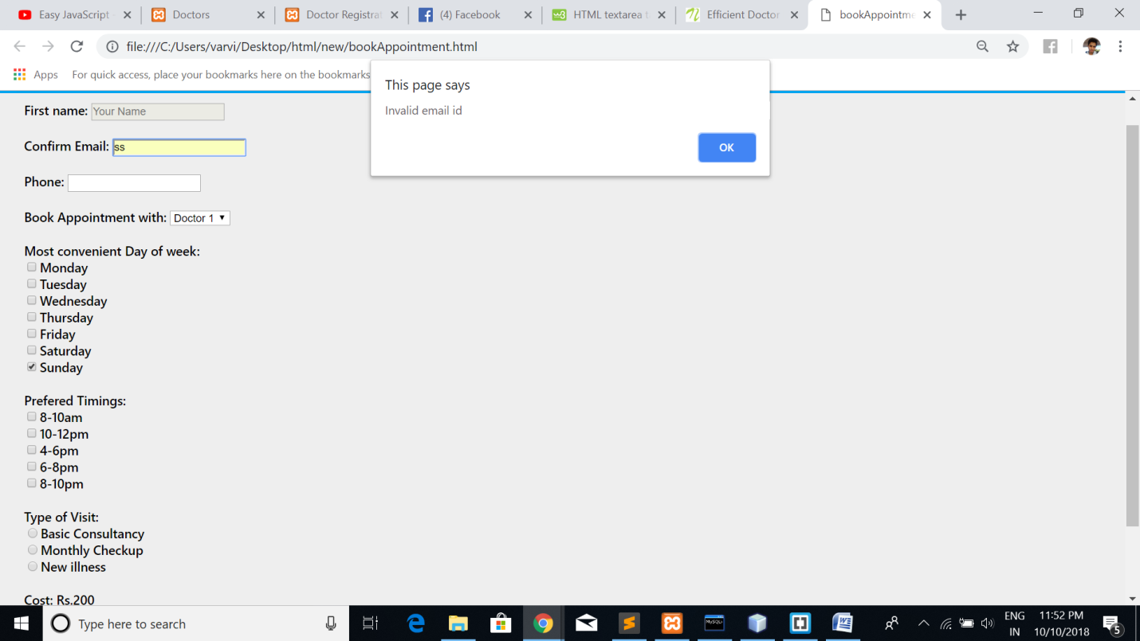

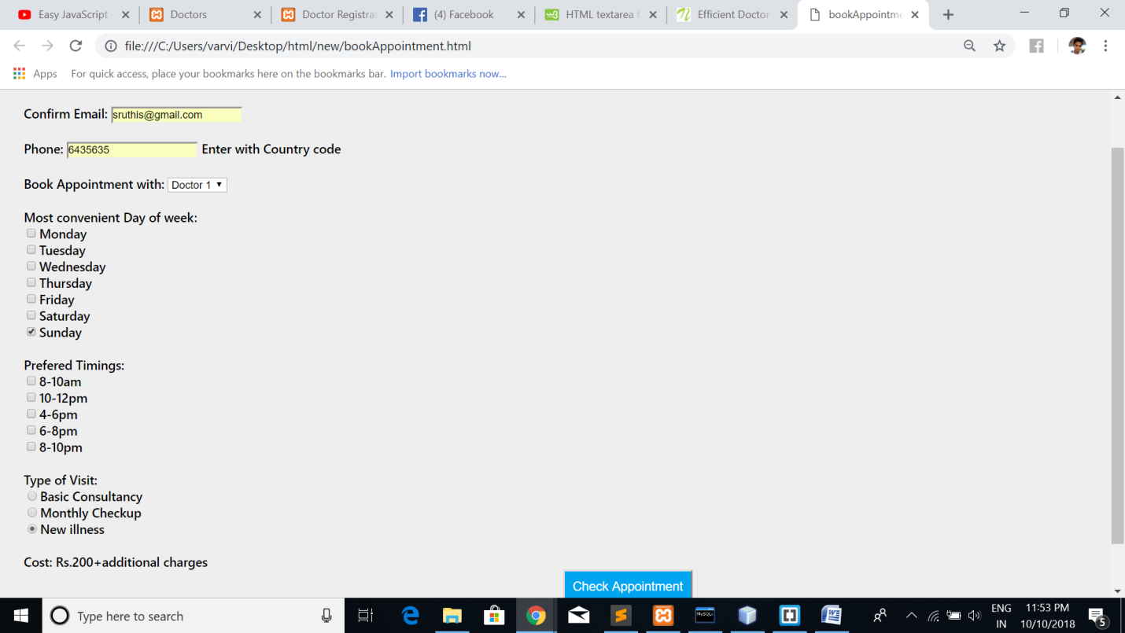

**RESULT:**

Hence the dynamic and validation using javascript implemented successfully.

**EXPERIMENT 5:**

**SERVER SIDE SCRIPTING USING SERVELET**

**AIM:**

To create dynamic page and perform validation using SERVELETS.

**PROCEDURE:**

1. Open Netbeans
2. Create servelet and map it in web.xml
3. Perform Get() and Post() function
4. Connect to html file
5. Execute the file in browser.

**SOURCE CODE:**

import java.io.IOException;

import java.io.PrintWriter;

import javax.servlet.ServletException;

import javax.servlet.http.Cookie;

import javax.servlet.http.HttpServlet;

import javax.servlet.http.HttpServletRequest;

import javax.servlet.http.HttpServletResponse;

/**

*

* @author varvi

*/

public class login1 extends HttpServlet {

@Override

protected void doGet(HttpServletRequest request, HttpServletResponse response)

throws ServletException, IOException {

response.setContentType("text/html;charset=UTF-8");

PrintWriter out = response.getWriter();

String user=request.getParameter("username");

String pass=request.getParameter("password");

if(user!=null && pass!=null)

{

if(user.equals("arvind") && pass.equals("1234"))

{

loginservelet.name="arvind";

Cookie cookie=new Cookie("username",loginservelet.name);

response.addCookie(cookie);

out.println("<!DOCTYPE html>\n" +

"<html>\n" +

"<style>\n" +

"body, html {\n" +

" height: 100%;\n" +

" margin: 0;\n" +

"}\n" +

"\n" +

".bgimg {\n" +

" background-image: url('/w3images/forestbridge.jpg');\n" +

" height: 100%;\n" +

" background-position: center;\n" +

" background-size: cover;\n" +

" position: relative;\n" +

" color: #01A4EF;\n" +

" font-family: \"Courier New\", Courier, monospace;\n" +

" font-size: 25px;\n" +

"}\n" +

"\n" +

".topleft {\n" +

" position: absolute;\n" +

" top: 0;\n" +

" left: 16px;\n" +

"}\n" +

"\n" +

".bottomleft {\n" +

" position: absolute;\n" +

" bottom: 0;\n" +

" left: 16px;\n" +

"}\n" +

"\n" +

".middle {\n" +

" position: absolute;\n" +

" top: 50%;\n" +

" left: 50%;\n" +

" transform: translate(-50%, -50%);\n" +

" text-align: center;\n" +

"}\n" +

"\n" +

"hr {\n" +

" margin: auto;\n" +

" width: 40%;\n" +

"}\n" +

"</style>\n" +

"<body>\n" +

"\n" +

"<div class=\"bgimg\">\n" +

" \n" +

" <div class=\"middle\">\n" +

" <h1>LOGIN SUCCESSFUL</h1>\n" +

" <hr>\n" +

" <a href=\"home.jsp\" >home</a>\n" +

" </div>\n" +

" <div class=\"bottomleft\">\n" +

" \n" +

" </div>\n" +

"</div>\n" +

"\n" +

"</body>\n" +

"</html>");

}

else

{

out.println("<!DOCTYPE html>\n" +

"<html>\n" +

"<style>\n" +

"body, html {\n" +

" height: 100%;\n" +

" margin: 0;\n" +

"}\n" +

"\n" +

".bgimg {\n" +

" background-image: url('/w3images/forestbridge.jpg');\n" +

" height: 100%;\n" +

" background-position: center;\n" +

" background-size: cover;\n" +

" position: relative;\n" +

" color: #01A4EF;\n" +

" font-family: \"Courier New\", Courier, monospace;\n" +

" font-size: 25px;\n" +

"}\n" +

"\n" +

".topleft {\n" +

" position: absolute;\n" +

" top: 0;\n" +

" left: 16px;\n" +

"}\n" +

"\n" +

".bottomleft {\n" +

" position: absolute;\n" +

" bottom: 0;\n" +

" left: 16px;\n" +

"}\n" +

"\n" +

".middle {\n" +

" position: absolute;\n" +

" top: 50%;\n" +

" left: 50%;\n" +

" transform: translate(-50%, -50%);\n" +

" text-align: center;\n" +

"}\n" +

"\n" +

"hr {\n" +

" margin: auto;\n" +

" width: 40%;\n" +

"}\n" +

"</style>\n" +

"<body>\n" +

"\n" +

"<div class=\"bgimg\">\n" +

" \n" +

" <div class=\"middle\">\n" +

" <h1>WRONG CREDENTIALS</h1>\n" +

" <hr>\n" +

" <a href=\"login.html\" >Back to Login</a>\n" +

" </div>\n" +

" <div class=\"bottomleft\">\n" +

" \n" +

" </div>\n" +

"</div>\n" +

"\n" +

"</body>\n" +

"</html>");

}

}

else

{

out.println("Empty username or password");

}

}

@Override

public String getServletInfo() {

return "Short description";

}// </editor-fold>

}

**OUTPUT:**

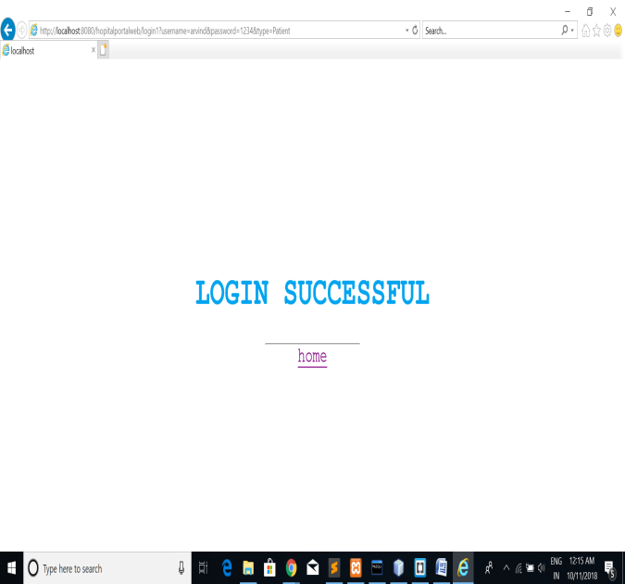 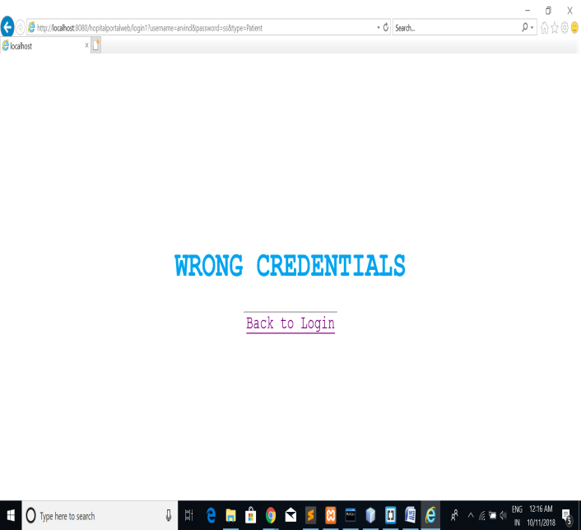

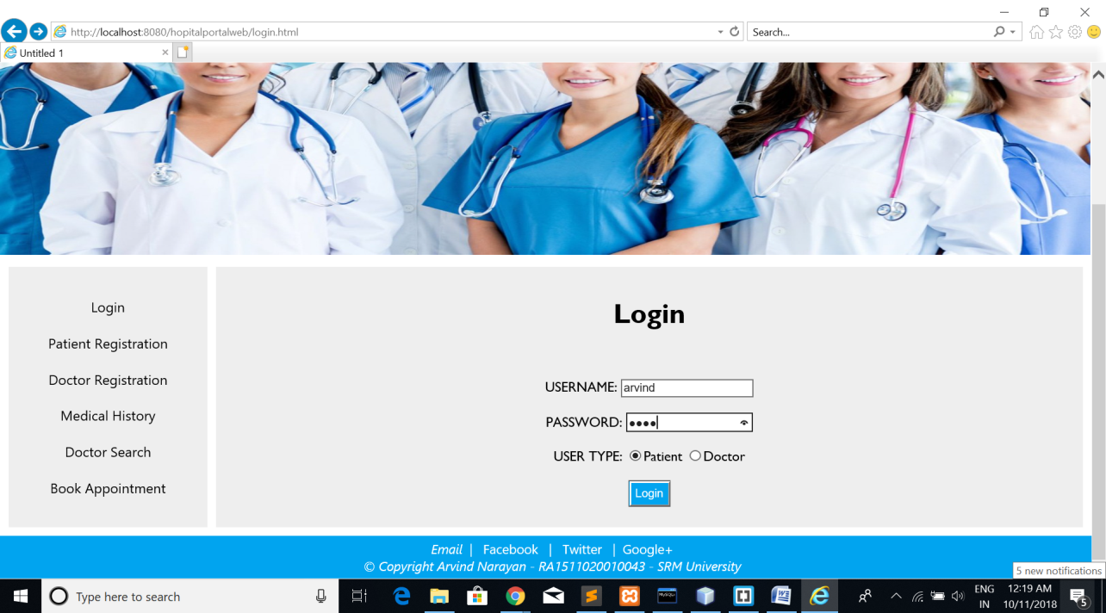

**RESULT:**

Hence the server side scripting using servelet were done successfully.

**EXPERIMENT 6:**

**SERVER SIDE SCRIPTING USING JSP**

**AIM:**

To create dynamic page and perform validation using SERVELETS.

**PROCEDURE:**

1. Open Netbeans
2. Create JSP page and add HTML in it
3. Perform cookies and Session tracking
4. Add scriptlets
5. Execute the file in browser.

**SOURCE CODE:**

<%--

Document : home

Created on : Oct 10, 2018, 5:29:18 PM

Author : varvi

--%>

<%@page contentType="text/html" pageEncoding="UTF-8"%>

<!DOCTYPE html>

<html>

<head>

<meta content="text/html; charset=utf-8" http-equiv="Content-Type" />

<title>Untitled 1</title>

<link href="index.css" rel="stylesheet" type="text/css">

<style type="text/css">

.auto-style1 {

font-style: normal;

font-size: 15px;

}

</style>

</head>

<body>

<header>

<div id="blueHeader">

<span id="title"> HospitalPortal</span>

<span id="headerNav"><a class="topNav" href="index.html" >Home</a>&nbsp;&nbsp;&nbsp; |&nbsp;&nbsp;&nbsp; <a class="topNav" href="login.html" >Login</a>&nbsp;&nbsp;&nbsp; |&nbsp;&nbsp;&nbsp; Appointment&nbsp;&nbsp; |&nbsp;&nbsp; Search</span>

<img src="stethoscope-simple-black-icon-512.png" alt="logo" id="blueLogo">

</div>

<img src="slider2.jpg" alt="doctors" id="doctors">

</header>

<main>

<table style="width: 100%">

<tr>

<td id="sideMenu">

<br><a href="login.html" class="nav"> Login </a> <br><br>

<a href="registration.html"class="nav" > Patient Registration </a><br><br>

<a href="registrationDoctor.html" class="nav" > Doctor Registration </a><br><br>

<a href="MedicalHistory.html" class="nav"> Medical History </a> <br><br>

<a href="DoctorSearch.html" class="nav" > Doctor Search </a> <br><br>

<a href="bookAppointment.html" class="nav"> Book Appointment </a> <br><br>

</td>

<td id="content" >

<%

Cookie cookie[]=request.getCookies();

int i=1;

for(Cookie c:cookie)

{

if(i==1)

{

out.print("Welcome " + "<i><b>"+ c.getValue()+","+"</b></i>");

i=0;

}

}

i=1;

%>

<p>The My HealthPoint patient portal, is a convenient, secure health management tool you can use anywhere you have access to the Internet. It provides access to important information about you and your visit(s) to our hospital.</p>

<p>Information available on My HealthPoint includes:</p>

<ul>

<li>

Admit and discharge dates and locations

</li>

<li>

Current and past problem list

</li>

<li>

Appointment booking and cancelation

</li>

<li>

Laboratory test results (available at time of discharge)

</li>

<li>

Family & social history

</li>

</ul>

<div>Not <%

i=1;

for(Cookie c:cookie)

{

if(i==1)

{

out.print("<i><b>"+c.getValue()+"</b></i>");

i=0;

}

}

i=1;

%> ? <a href="login.html" class="nav" >logout</a>

</div>

</td>

</tr>

</table>

</main>

<footer>

<span class="auto-style1">Email&nbsp; </span><span id="preFooter">|&nbsp;&nbsp; Facebook&nbsp;&nbsp; |&nbsp;&nbsp; Twitter&nbsp;&nbsp; |&nbsp;

Google+ </span><br>

&copy; Copyright Arvind Narayan - RA1511020010043 - SRM University

</footer>

</body>

</html>

**OUTPUT:**

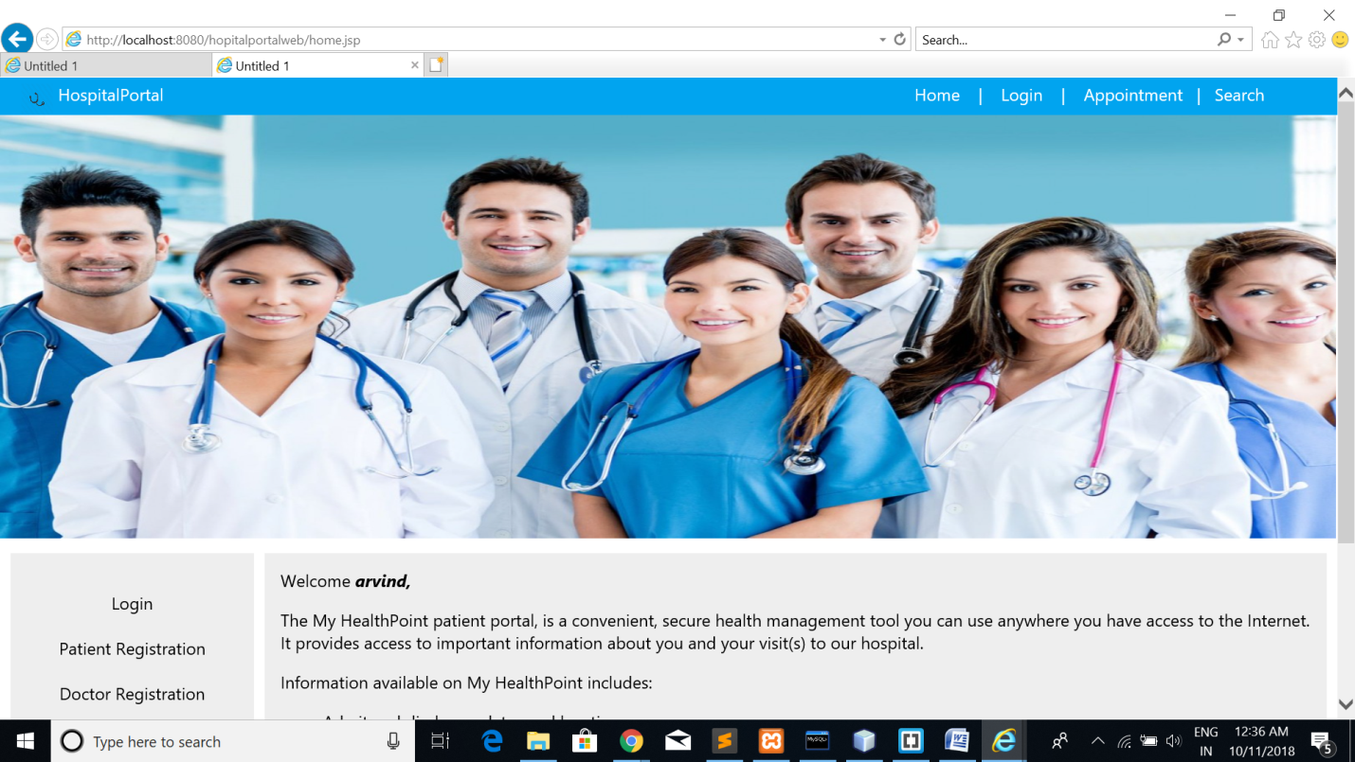

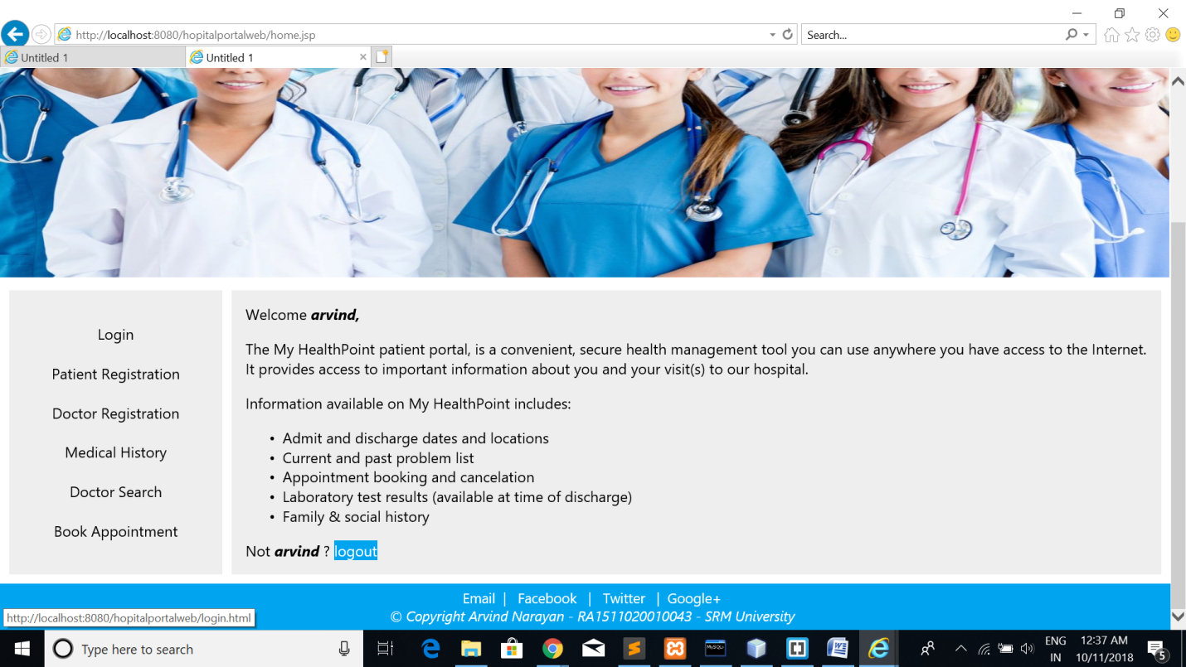

**RESULT:**

Hence the server side scripting using JSP were done successfully.

**EXPERIMENT 7:**

**DYNAMIC RESPONSE GENERATION USING AJAX**

**AIM:**

To create dynamic response using AJAX.

**PROCEDURE:**

1. Open Netbeans
2. Create a HTML page and add Javascript
3. Add HttpResponse in the script
4. Create a response dynamically
5. Execute the file in browser.

**SOURCE CODE:**

<!DOCTYPE html>

<html>

<head>

<title>AJAX</title>

<script src="script.js"></script>

<link href="bookAppointment.css" rel="stylesheet" type="text/css">

</head>

<body>

<header>

<div id="blueHeader">

<span id="title" >HospitalPortal </span>

<span id="headerNav"><a href="index.html" style="color:#FFFFFF" >Home</a>&nbsp;&nbsp;&nbsp; |&nbsp;&nbsp;&nbsp; <a class="topNav" href="login.html" style="color:#FFFFFF">Login</a>&nbsp;&nbsp;&nbsp; |&nbsp;&nbsp;&nbsp; Appointment&nbsp;&nbsp; |&nbsp;&nbsp; Search</span>

<img src="stethoscope-simple-black-icon-512.png" alt="logo" id="blueLogo">

</div>

</header>

<div id="divpadding">

<h2 style="margin-left: 40%;">Feedback Form</h2>

<br><br>

<form name="feedback">

Name: <input type="text" name="name"><br><br>

Hospital infrastructure:<br> <input type="radio" name="infra" value="Excellent">Excellent<br>

<input type="radio" name="infra" value="good">Good<br>

<input type="radio" name="infra" value="bad">Bad<br><br>

Doctors' Efficiency: <br><input type="radio" name="doceff" value="Excellent">Excellent<br>

<input type="radio" name="doceff" value="good">Good<br>

<input type="radio" name="doceff" value="bad">Bad<br><br>

Hospital Portal: <br><input type="radio" name="portal" value="Excellent">Excellent<br>

<input type="radio" name="portal" value="good">Good<br>

<input type="radio" name="portal" value="bad">Bad<br><br>

</form>

<button id="getText">Do you have any other to say?</button>

<div id="content" ></div>

<br><br>

<input type="submit" style="margin-left:50%;" value="submit">

</div>

<footer>

<span class="auto-style1">Email&nbsp; </span><span id="preFooter">|&nbsp;&nbsp; Facebook&nbsp;&nbsp; |&nbsp;&nbsp; Twitter&nbsp;&nbsp; |&nbsp;

Google+ </span><br>

&copy; Copyright Arvind Narayan - RA1511020010043 - SRM University

</footer>

</html>

*Script:*

window.onload=function()

{

var getText=document.getElementById("getText");

var content=document.getElementById("content");

var xhr=new XMLHttpRequest();

getText.addEventListener("click",function(){

xhr.addEventListener('readystatechange',function(){

content.innerHTML=this.responseText;

});

xhr.open("GET","test.txt",true);

xhr.send();

});

};

**OUTPUT:**

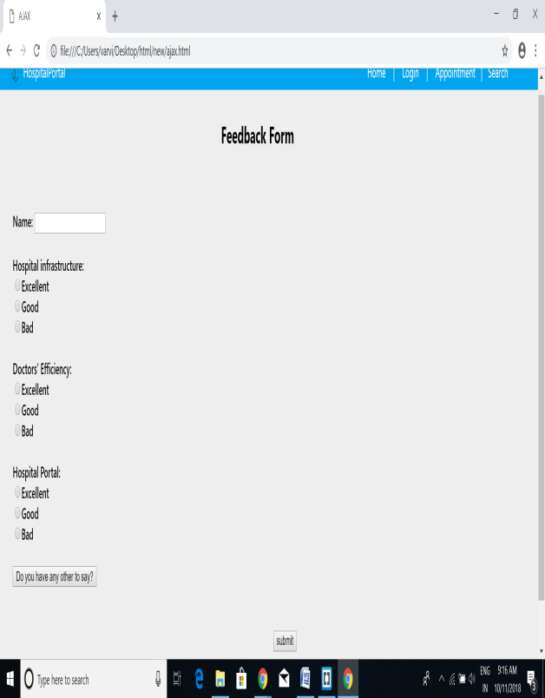 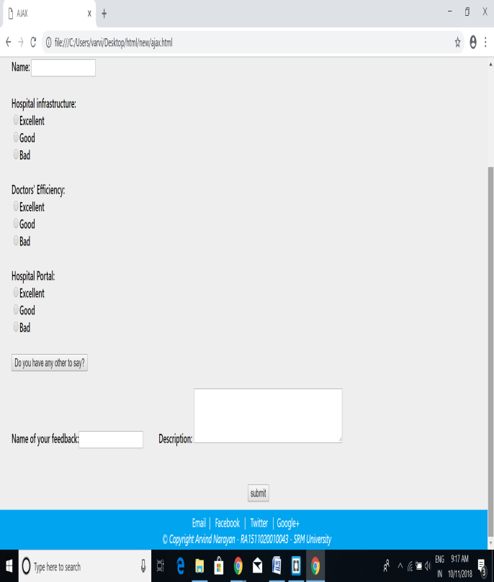

**RESULT:**

Hence the dynamic response was generated done successfully.

**EXPERIMENT 8:**

**WEB PAGE USING PHP**

**AIM:**

To create a webpage using PHP.

**PROCEDURE:**

1. Open Netbeans
2. Create a HTML page and add PHP
3. Open XAMPP and start server
4. Connect to the database
5. Execute the file in browser.

**SOURCE CODE:**

<!DOCTYPE html>

<html>

<head>

<title>Doctors</title>

<style type="text/css">

#blueHeader {

background-color: #01A4EF;

font-weight: 400;

color: white;

margin: 0px auto;

padding: 5px;

padding-left: 20px;

height: 25px;

}

#title {

padding: 5px;

}

#headerNav

{

margin-left: 700px;

}

#blueLogo {

width: 30px;

height: 30px;

float: left;

}

#doctors

{

width: 1262px;

height: 300px;

}

#divpadding

{

background-color: #eeeeee;

margin: 0px auto;

padding:10px;

padding-left:30px;

height: 82vh;

}

h2 { color: #ff4411; font-family: 'Signika', sans-serif; padding-bottom: 10px; }

h1 {

font-family:Georgia,serif;

color: #1a53ff;

font-size:30px;

line-height:1em;

margin:0 0 0 60px;

margin-left: 25%;

margin-bottom: 20px;

padding-bottom: 20px;

}

h1 strong{

color: #1a53ff;

display:block;

font-size:85px;

font-weight:normal;

letter-spacing:-3.5px;

line-height:1em;

}

table {

border-collapse: collapse;

width: 100%;

}

th, td {

text-align: left;

padding: 8px;

}

tr:nth-child(even){background-color: #cce0ff}

tr:nth-child(odd){background-color: #ccccff}

th {

background-color: #cc0000;

color: white;

}

body {

font-family: "Segoe UI", Tahoma, Geneva, Verdana, sans-serif;

font-weight: 500;

margin: 0 auto;

}

a{

text-decoration:none;

}

footer {

background-color: #01A4EF;

font-weight: 400;

color: white;

margin: 0px auto;

padding: 5px;

padding-left: 20px;

height: 40px;

font-style: italic;

text-align:center;

font-size: 15px;

}

.auto-style1 {

font-style: normal;

font-size: 15px;

}

#preFooter {

font-style: normal;

}

#submit

{

margin-left:50%;

padding:10px;

color:#FFFFFF;

font-size:medium;

background-color:#01A4EF;

}

</style>

</head>

<body>

<header>

<div id="blueHeader">

<span id="title" >HospitalPortal </span>

<span id="headerNav"><a href="index.html" style="color:#FFFFFF" >Home</a>&nbsp;&nbsp;&nbsp; |&nbsp;&nbsp;&nbsp; <a class="topNav" href="login.html" style="color:#FFFFFF">Login</a>&nbsp;&nbsp;&nbsp; |&nbsp;&nbsp;&nbsp; Appointment&nbsp;&nbsp; |&nbsp;&nbsp; Search</span>

<img src="stethoscope-simple-black-icon-512.png" alt="logo" id="blueLogo">

</div>

</header>

<div id="divpadding">

<br>

<h1><strong>Doctor Details</strong></h1>

<br>

<?php

/* Attempt MySQL server connection. Assuming you are running MySQL

server with default setting (user 'root' with no password) */

$link = mysqli_connect("localhost", "root", "root", "web");

// Check connection

if($link === false){

die("ERROR: Could not connect. " . mysqli_connect_error());

}

// Attempt select query execution

$sql = "SELECT * FROM login";

if($result = mysqli_query($link, $sql)){

if(mysqli_num_rows($result) > 0){

echo "<table>";

echo "<tr>";

echo "<th>id</th>";

echo "<th>first_name</th>";

echo "<th>last_name</th>";

echo "</tr>";

while($row = mysqli_fetch_array($result)){

echo "<tr>";

echo "<td>" . $row['uname'] . "</td>";

echo "<td>" . $row['pass'] . "</td>";

echo "<td>" . $row['type'] . "</td>";

echo "</tr>";

}

echo "</table>";

// Free result set

mysqli_free_result($result);

} else{

echo "No records matching your query were found.";

}

} else{

echo "ERROR: Could not able to execute $sql. " . mysqli_error($link);

}

// Close connection

mysqli_close($link);

?>

</div>

<footer>

<span class="auto-style1">Email&nbsp; </span><span id="preFooter">|&nbsp;&nbsp; Facebook&nbsp;&nbsp; |&nbsp;&nbsp; Twitter&nbsp;&nbsp; |&nbsp;

Google+ </span><br>

&copy; Copyright Arvind Narayan - RA1511020010043 - SRM University

</footer>

</body>

</html>

**OUTPUT:**

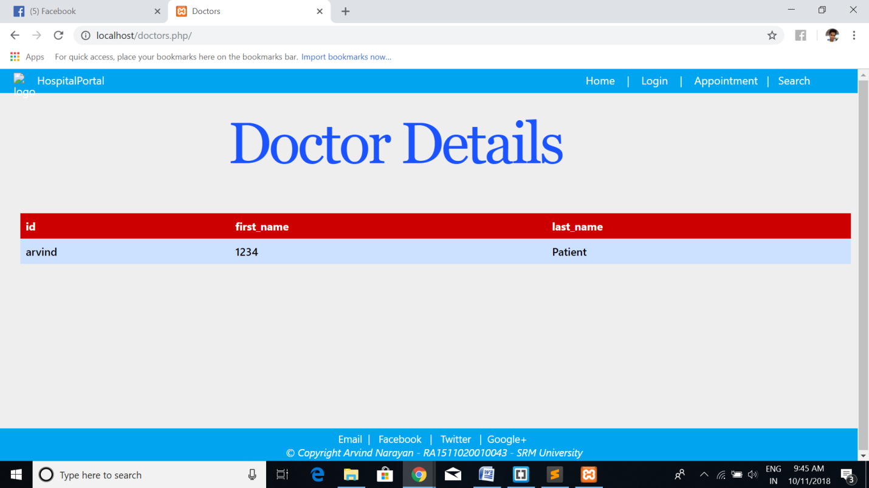

**RESULT:**

Hence server side scripting using php was done successfully.

**EXPERIMENT 9:**

**XML**

**AIM:**

To create xml page and use DTD,XSD and XSLT.

**PROCEDURE:**

1. Open Text editor
2. Create xml file.
3. Create DTD file
4. Create XSD file
5. Apply XSLT to xml.

**SOURCE CODE:**

XML:

<!DOCTYPE doctors SYSTEM "C://Users/varvi/Desktop/html/new/doctor.dtd">

<doctors>

<doctor id='101'>

<name>Arvind</name>

<email>varvind7@gmail.com</email>

<dept>Ortho</dept>

<mobile>745745</mobile>

<qual>MBBS</qual>

</doctor>

<doctor id='102'>

<name>Ram</name>

<email>ram7@gmail.com</email>

<dept>ENT</dept>

<mobile>7457445</mobile>

<qual>MBBS</qual>

</doctor>

<doctor id='103'>

<name>Hari</name>

<email>hari@gmail.com</email>

<dept>general</dept>

<mobile>7457454</mobile>

<qual>MBBS</qual>

<qual>MS</qual>

</doctor>

</doctors>

DTD:

<!ELEMENT doctors (doctor*)>

<!ELEMENT doctor (name,email,dept,mobile,qual+) >

<!ATTLIST doctor id CDATA #REQUIRED>

<!ELEMENT name (#PCDATA)>

<!ELEMENT email (#PCDATA)>

<!ELEMENT dept (#PCDATA)>

<!ELEMENT mobile (#PCDATA)>

<!ELEMENT qual (#PCDATA)>

XSD:

<schema targetNamespace="http://www.docinfo.com"

xmlns="http://www.w3.org/2001/XMLSchema"

elementFormDefault="qualified">

<element name="doctors">

<complexType>

<sequence>

<element name="doctor" minOccurs="0" maxOccurs="unbounded">

<complexType>

<sequence>

<element name="name" type="string"/>

<element name="email" type="string"/>

<element name="dept" type="string"/>

<element name="mobile">

<simpleType>

<restriction base="int">

<pattern value="[0-9]{10}"/>

</restriction>

</simpleType>

</element>

<element name="qual" type="string" minOccurs="1" maxOccurs="unbounded"/>

</sequence>

</complexType>

</element>

</sequence>

</complexType>

</element>

</schema>

XSL:

<?xml version="1.0" encoding="UTF-8"?>

<xsl:stylesheet version="2.0" xmlns:xsl="http://www.w3.org/1999/XSL/Transform">

<xsl:template match="/doctors">

<html>

<body>

<xsl:for-each select="doctor">

<xsl:value-of select="name"><br/>

<xsl:value-of select="email"><br/>

<xsl:value-of select="dept"><br/>

<xsl:value-of select="mobile"><br/>

<xsl:value-of select="name"><br/>

</xsl:for-each>

</body>

</html>

<xsltemplate>

</xsl:stylesheet>

**OUTPUT:**

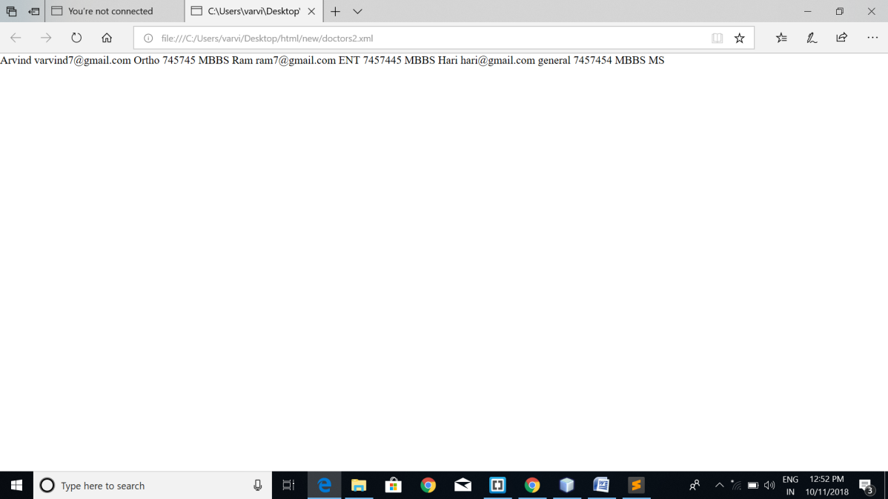

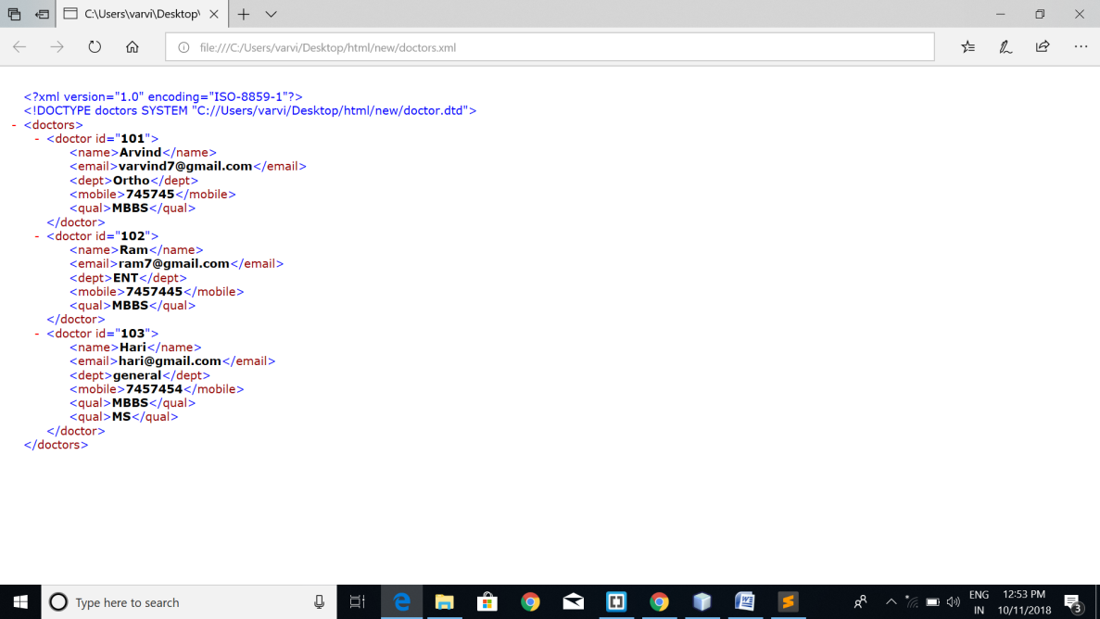

**RESULT:**

Hence XML files and DTD,XSD files were created successfully.

**EXPERIMENT 10:**

**WEB SERVICES**

**AIM:**

To create a web service using Java web service in NetBeans.

**PROCEDURE:**

1. Open Text editor
2. Create xml file.
3. Create DTD file
4. Create XSD file
5. Apply XSLT to xml.

**SOURCE CODE:**

Client side HTML code:

<%--

Document : testservice

Created on : Oct 7, 2018, 10:27:00 PM

Author : varvi

--%>

<%@page contentType="text/html" pageEncoding="UTF-8"%>

<!DOCTYPE html>

<html>

<head>

<meta http-equiv="Content-Type" content="text/html; charset=UTF-8">

<title>JSP Page</title>

<link href="bookAppointment.css" rel="stylesheet" type="text/css">

</head>

<body>

<header>

<div id="blueHeader">

<span id="title" >HospitalPortal </span>

<span id="headerNav"><a href="index.html" style="color:#FFFFFF" >Home</a>&nbsp;&nbsp;&nbsp; |&nbsp;&nbsp;&nbsp; <a class="topNav" href="login.html" style="color:#FFFFFF">Login</a>&nbsp;&nbsp;&nbsp; |&nbsp;&nbsp;&nbsp; Appointment&nbsp;&nbsp; |&nbsp;&nbsp; Search</span>

<img src="stethoscope-simple-black-icon-512.png" alt="logo" id="blueLogo">

</div>

</header>

<div id="divpadding">

<h2 style="margin-left: 30%;">Diet Chart for various Diseases</h2>

<br>

<p>Select your illness</p>

<br>

<form name="f1" method="get" action="client">

<input type="radio" name="illness" value="fever">Fever

<br>

<input type="radio" name="illness" value="cough">Cough

<br><br>

<input type="submit" name="submit" value="Get Diet">

</form>

</div>

<footer>

<span class="auto-style1">Email&nbsp; </span><span id="preFooter">|&nbsp;&nbsp; Facebook&nbsp;&nbsp; |&nbsp;&nbsp; Twitter&nbsp;&nbsp; |&nbsp;

Google+ </span><br>

&copy; Copyright Arvind Narayan - RA1511020010043 - SRM University

</footer>

</body>

</html>

Clientside Servelet Code:

import java.io.IOException;

import java.io.PrintWriter;

import javax.servlet.ServletException;

import javax.servlet.http.HttpServlet;

import javax.servlet.http.HttpServletRequest;

import javax.servlet.http.HttpServletResponse;

import javax.xml.ws.WebServiceRef;

import server.Sayhello_Service;

/**

*

* @author varvi

*/

public class client extends HttpServlet {

@WebServiceRef(wsdlLocation = "WEB-INF/wsdl/localhost_8080/hospservice/sayhello.wsdl")

private Sayhello_Service service;

protected void processRequest(HttpServletRequest request, HttpServletResponse response)

throws ServletException, IOException {

response.setContentType("text/html;charset=UTF-8");

PrintWriter out = response.getWriter();

String name=request.getParameter("illness");

try {

/* TODO output your page here. You may use following sample code. */

server.Sayhello port = service.getSayhelloPort();

java.lang.String arg0=name;

java.lang.String result=port.hello(arg0);

out.println(result);

}catch(Exception e)

{

}

}

// <editor-fold defaultstate="collapsed" desc="HttpServlet methods. Click on the + sign on the left to edit the code.">

/**

* Handles the HTTP <code>GET</code> method.

*

* @param request servlet request

* @param response servlet response

* @throws ServletException if a servlet-specific error occurs

* @throws IOException if an I/O error occurs

*/

@Override

protected void doGet(HttpServletRequest request, HttpServletResponse response)

throws ServletException, IOException {

processRequest(request, response);

}

/**

* Handles the HTTP <code>POST</code> method.

*

* @param request servlet request

* @param response servlet response

* @throws ServletException if a servlet-specific error occurs

* @throws IOException if an I/O error occurs

*/

@Override

protected void doPost(HttpServletRequest request, HttpServletResponse response)

throws ServletException, IOException {

processRequest(request, response);

}

/**

* Returns a short description of the servlet.

*

* @return a String containing servlet description

*/

@Override

public String getServletInfo() {

return "Short description";

}// </editor-fold>

}

Web service:

package server;

import javax.jws.WebService;

import javax.jws.WebMethod;

import javax.jws.WebParam;

/**

*

* @author varvi

*/

@WebService(serviceName = "sayhello")

public class sayhello {

/**

* This is a sample web service operation

*/

@WebMethod

public String hello(String txt) {

String diet=null;

if(txt.equals("fever"))

{

diet="The list of foods below is beneficial for reducing fever:<br>" +

"<br>" +

"Fluid-rich foods: Drink water, hot tea, fresh fruit juice. Intake of fluid-rich foods is recommended such as poultry broths, thin soups, coconut water.<br>" +

"Fresh fruits: Fruits like apples, oranges, watermelon, pineapple, kiwi are rich in vitamin C. This contains antioxidants that reduce fever.<br>" +

"Avoid fruits with heavy sugar and fruits canned in syrup because sugar inhibits the immune system. The banana provides vital nutrients and easy to digest.<br>" +

"Proper intake of proteins: Scrambled eggs, smoothie with low-fat milk, dal, chana or Indian cottage cheese are rich in protein and beneficial.";

}

if(txt.equals("cough"))

{

diet="Here’s a list of food to go for when trying to tame a cough: <br>" +

"<br>" +

"Honey – honey is a traditional remedy for coughs, and in one study parents rated honey most favourably for symptomatic relief of their child's nocturnal cough. This is more suitable for older children.<br>" +

"Probiotics –there may be some benefits in taking Lactobacillus to reduce the likelihood of a cold or flu.<br>" +

"Pineapple – bromelain, a mixture of enzymes naturally found in pineapples, may help suppress coughs and loosen mucus.<br>" +

"Chicken soup – some studies have suggested that this old-time remedy may actually be able to assist with, colds – one study suggested this could even help with mucus congestion in the nasal passages. <br>" +

"Liquorice root tea - as well as being a soothing drink that can help you to relax when you’re feeling blocked up and poorly, liquorice is a traditional treatment for cough and sore throat and is thought to soothe airways and thin mucus.";

}

return diet;

}

}

**OUTPUT:**

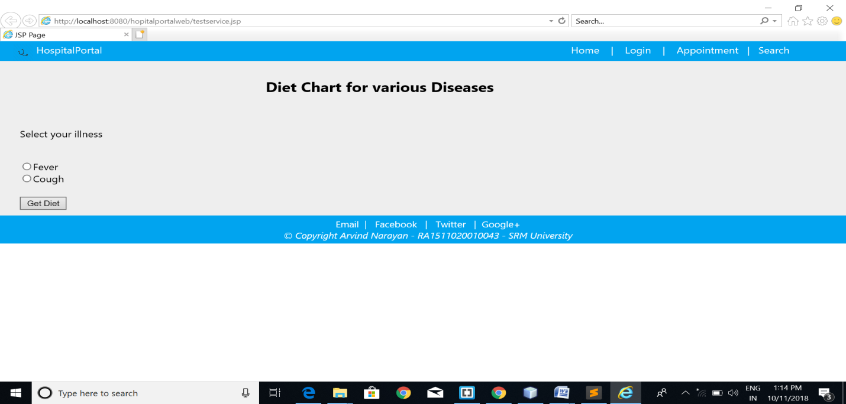

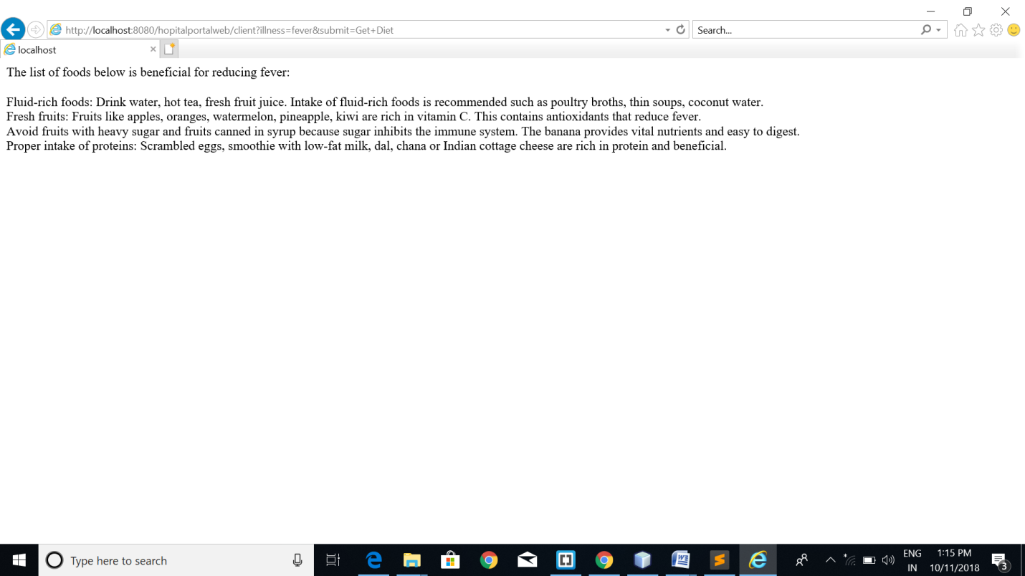

**RESULT:**

Hence webservices in NetBeans was executed successfully.